git add .
git commit -m "your comment"
git push

to update the file.

Word Count: 11 Character Count: 62 Sentences count: 3

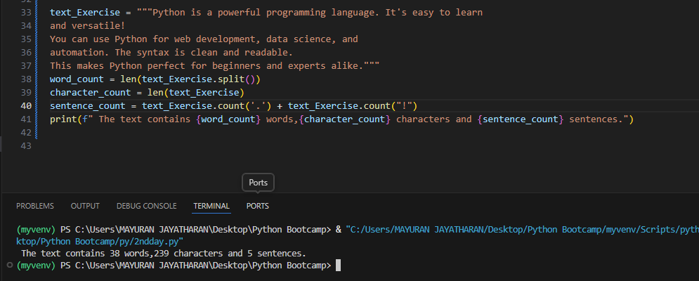

Set-ExecutionPolicy -Scope Process -ExecutionPolicy Bypass – to bypass the error
myvenv\Scripts\activate – For activating the environment

